COVER VALET INSTALLATION INSTRUCTIONS
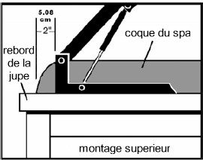

Steps 1 to 6 Pre-assembly:
- Unpack all parts and check for missing parts (see Cover Valet Parts and Hardware List).
- Attach the ball studs (cvB) to each of the U-brackets (cvBB) using the clamping nuts (cvF). The ball joint (rounded part) of the pivot (cvB) must be inside the U-bracket (cvBB).
- Attach the ball studs (cvB) to each of the pivot arms (cvCC) with the clamp nuts (cvF).
- Screw the threaded rods (cvEE) into the extensions (cvDD). The second pair of rods (cvEE) must be screwed in the opposite direction to the first in order to have a lever on the left and one on the right.
- Slide the rubber sleeves (cvG) and (cvH) onto the stabilizer (cvFF) and rods (cvEE) respectively.
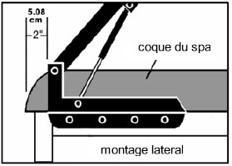
- Lay the cover on the spa and center it.

At this stage, you must determine which type of mounting to adopt: top mounting or side mounting.
TOP MOUNT
(example: wide rim spa, built-in or buried spa)
- Position the U-Brackets (cvBB) on the edge of the spa or on the deck or covering that surrounds the spa, so that the rear end of the U-Bracket (cvBB) is 2" from the back of the acrylic shell and is parallel to the spa cover. ***Pre-drilling all holes is recommended***
- Attach the U-brackets (cvBB) to the sill or surround using 4 or 5 lag bolts (cvA) on each side.

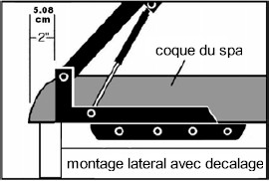
Note: If you choose a top mount, you will have extra parts: 2 side brackets (cvAA), 10 medium hex head screws (cvD) and 10 clamp nuts (cvF). Possibly 2 lag bolts (cvA). The upper assembly is now complete, go directly to step 7.

SIDE MOUNT
(example: the spa shell and/or cover is wider than the spa skirt)

Position the side mounting brackets (cvAA) so that the following four conditions are met:
- The rounded holes in the side mounting bracket (cvAA) should be placed against the spa skirt and the slots should be at the top.
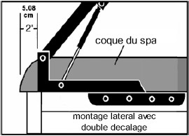
- The side mounting brackets (cvAA) should be placed just below (or parallel to) the acrylic shell
- The back end of the U-Bracket (cvBB) should be 2" from the back of the acrylic shell and should be parallel to the spa cover, resting on the side mounting bracket ( cvAA).
At least 5 slots, and in any case not less than 4 slots in the U-Bracket (cvBB) must line up with the slots in the Side Bracket (cvAA). ***Pre-drilling all holes is recommended***
Attach the side mounting brackets (cvAA) to the spa using 4 lag bolts (cvA) on each side. Then attach the U-brackets (cvBB) to the side brackets (cvAA) using 5, and in any case no less than 4 medium-sized hex head screws (cvD) and clamping nuts ( cvF). The nuts (cvF) must be placed under the upper part of the side fixing bracket (cvAA).
Note: If you choose side mounting, you will have extra parts: 2 lag screws (cvA) and possibly 2 medium hex head screws (cvD) and 2 clamping nuts (cvF), depending on whether you have fixed or not the leg offset from the square.
ASSEMBLAGE FINAL :

- Snap the bottom of the lockable gas strut (cvLS) onto the ball stud (cvB) attached to the U-bracket (cvBB) pressing down until you hear a click. The lockable gas strut (cvLS) should be installed on the side you will most often use to open and close the cover.
Then press the lower end of the normal gas strut (cvRS) to engage the other ball stud (cvB) attached to the other U-bracket (cvBB) until you hear a snap.

* Leave the gas shocks (cvLS and cvRS) in the U-brackets (cvBB) for now.*
- Slide the cover about one meter away from the lifting mechanism
- Secure the swing arms (cvCC) to the U-brackets (cvBB) using the long hex head screws (cvC) and clamp nuts (cvF). The clamping nuts (cvF) should be on the outside of the U-brackets (cvBB) and tightened so that the swing arms (cvCC) can be easily raised and lowered. -CAUTION: DO NOT TIGHTEN TOO STRONG-
- Slip the center seam of the cover between the two rods (cvEE), the extensions (cvDD) being in line with the pivoting arms (cvCC). The bottom rod should be under the cover while the top rod should be on top of the cover. The fork at the end of the extension must be facing up, visible, and the flat part must be below (Photo Good position, fork above).

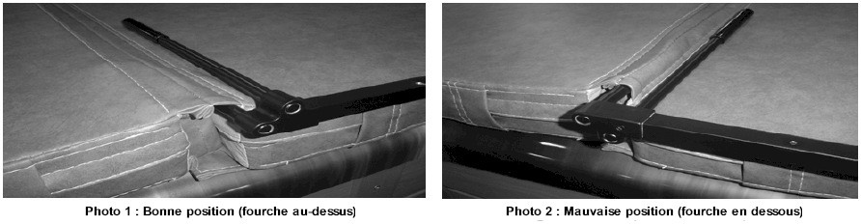
--Warning, the fork may be mounted INCORRECTLY. Improper assembly will cause excessive tension on the seams, risk damaging the cover as well as the Cover Valet mechanism, and will prevent any guarantee from applying. !
- 11. Position the extensions (cvDD) so that they can slide into the swing arms (cvCC). Gently adjust the assembly until the cover is again centered on the spa, as in step 6.
- Fixez solidement les stabilisateurs (cvFF) et les rallonges (cvDD) aux bras pivotants (cvCC) à l’aide des vis à tête hexagonale moyennes (cvE). Serrez suffisamment pour que les rallonges (cvDD) ne puissent plus glisser à l’intérieur des bras pivotants (cvCC) et que les stabilisateurs (cvFF) ne bougent plus.

- CAUTION: DO NOT TIGHTEN TOO STRONG-
- Fold the cover back on itself, then manually operate the Cover Valet mechanism to place the cover in the upright position. To do this, pull or push the bar in the middle of the cover or the extension (cvDD) upwards, immobilizing it at the back of the spa in a vertical position. While holding the cover up, attach the top of the Normal Gas Shock (cvRS) to the Ball Pivot (cvB) on the Pivot Arm (cvCC). Gently return the cover to the horizontal position then repeat this step on the other side to attach the Locking Gas Strut (cvLS).
- Attach the ball (cvJ) by its rubber band to the rod (cvEE) located on the side of the locking damper (cvS) (grab the ball (cvJ) to fold the cover rather than pulling the flaps of the cover).

COVER VALET COVER VALET COVER LIFT CARE INSTRUCTIONS

The Cover Valet cover lifter is designed for a specific use. It is not designed to be BENDED, DEFORMED or ABUSED. Never stand, sit, lie down or place a heavy object on the cover or mechanism. Do not clean with abrasive products, solvents or strong detergents. The equipment is provided with a zinc coating which gives it great durability, but any exposure to large doses of chlorine, bromine, ozone or other active chemicals can cause premature deterioration. Check screws and bolts often and adjust if necessary. Any part showing signs of wear must be replaced immediately.

To order a spare part, a missing part or for any special order, call 04-50-18-47-79 or contact us via our website http://montblancspas.com.

The Cover Valet lifter should be handled with care to ensure proper operation and longevity. These instructions for use and maintenance are provided to you to avoid any risk of damage. Any damage caused by failure to follow the maintenance and use instructions will be excluded from the manufacturer's warranty.

COVERVALET COVER LIFTER USER MANUAL

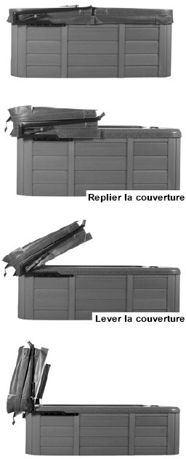
Comment FERMER your spa cover using Cover Valet: :

When the cover is in the upright position, press
TOUJOURS s
press and hold the orange lockable gas strut button while lowering the cover. By holding down this button, the mechanism remains "open" and your cover can be closed smoothly. If you do not press the orange button while the cover is closing, you risk damaging the mechanism, the spa and the cover!
Gently guide the mechanism and cover down to rest the assembly on the spa. Don't let JAMAIS the cover falling on the spa shell without holding it, this could damage the mechanism, the spa and the cover!
Unfold the cover and close the locks if applicable.
How to OPEN your spa cover using the Cover Valet device:

Unlock the cover if applicable. Fold the blanket back on itself.
Depending on whether you are standing at the front or back of the spa, pull or push the bar in the middle of the cover or the extender up and back of the spa to swing the cover into the upright position. The locking damper should “click” when the cover is in the correct position.

NEVER LEAVE AN UNCOVERED HOT TUB OR SPA UNATTENDED.

NEVER LEAVE A COVERED WHIRLPOOL OR SPA UNLOCKED.
Cover Valet Parts and Hardware List

To order a spare part, a missing part or for any special order, call 04-50-18-47-79 or contact us via our website http://www.tubs.fr.

Symbol Quantity Part Description cvAA 2 Lateral mounting bracket cvBB 2 U-square
cvCC 2 Swivel arm
cvDD 2 Extension
cvEE 4 Very
cvFF 2 Stabilizer
cvLS 1 Lockable damper
cvRS 1 standard shock absorber

Symbol Quantity Material Description
Recommended tools
- Ruler or meter
- Drill and bitsCliquet
- 3/8˝ extension
- 1/2˝ socket
- 2 ½" wrenches
- Key of 11
- Crayon

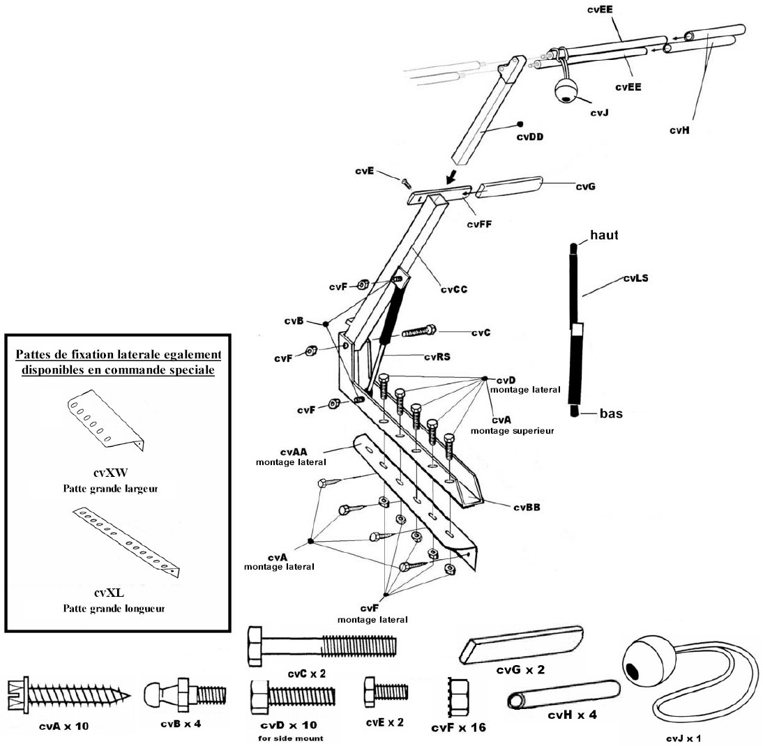
cvA | 10 | Tire- fond
cvB | 4 | Ball joint
cvC | 2 | Long Hex head screw
cvD | 10 | Medium Hex head screw
cvE | 2 | Small Hex head screw
cvF | 16 | Clamping nut
cvG | 2 | Sleeve for stabilizer
cvH | 4 | Sleeve for threaded rod
cvJ | 1 | Ball and bungee attachment

California Home Spas, INC.
Cover Rock-It - 5 Year Limited Warranty
The Cover Rock-It cover lifter is guaranteed for parts and labor for a period of five years from the date of purchase. If during the warranty period the product fails due to a defect in material or workmanship, it will be repaired or replaced, at the option of California Home Spas, INC. (the cost of transport to and from the manufacturer's premises is excluded from the warranty).

EXCLUSIONS : This warranty does not cover
- damage resulting from use of the Cover Rock-It and/or spa cover not in accordance with the care and use documents provided by California Home Spas, INC.. ;
- defects in parts that are not Cover Rock-It cover lifter components;
- any damage or accident resulting from misuse or abuse of the Cover Rock-It, negligence, or any alteration that is not included in the warranty as specified by California Home Spas, INC.;
- Normal fading and minor deterioration due to exposure to weather, sun, chemicals or other environmental factors;
- damage resulting from the use of solvents, abrasive cleaning products or tools and corrosive detergents.

*** Except as otherwise provided, no additional warranties may be given, expressed or implied, orally or in writing.***

WARNINGS :
- California Home Spas, INC. shall not be liable for any consequential damages or incidental expenses resulting from any breach of the foregoing warranty.
- This warranty gives you specific legal rights, and you may also have other rights depending on the state or country in which you reside..
- C. Any dispute between Buyer and California Home Spas, INC. covered by this warranty may be terminated, at Buyer's option, in accordance with the rules of the American Arbitration Association in the State of California, United States..
- D. If one or more clauses, provisions, endorsements or conditions of this guarantee are declared null, invalid, illegal or illicit in any way whatsoever, the other terms and conditions of this guarantee will not be modified and will remain in effect.

