Guide d’installation du Cover ROCK-IT

- Lay out all the parts and check that they are all present according to the instruction manual for explosion-proof parts and the instruction manual.

Products | Amount
Plastic pivot | 4
Hex screw | 2
Flat washer | 4
Nut | 2
Self tapping screw | About ten
Black cap | 2 different sizes
Base bracket | 2
Pivot arm | 2
Support tube | 2
Connect tube | 2

- Position your spa cover (in the closed position) on the spa, making sure that the four corners of the cover are aligned with the four corners of the spa.

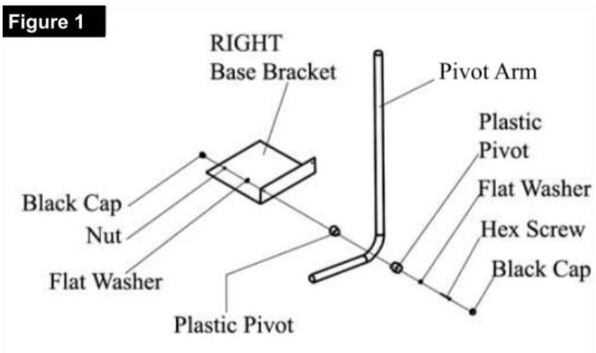
Step1
Bring the following parts:
  - 2 black caps
  - 1 nut
  - 2 flat washers
  - 1 basic support
  - 1 plastic swivel
  - 1 swivel arm
  - 1 hex screw

Step 2
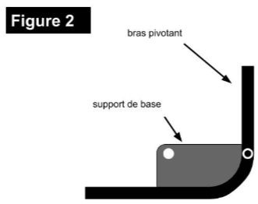
Insert the parts in the order of Figure 1 and assemble the left side of the base of your
cover lifter (Figure 2). Repeat the same operation for the right side.

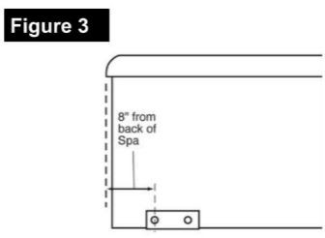
Step 3
Slide the base supports under your drained spa (Figure 3). You may need assistance from a third party.
Make sure the base supports are inserted 8" or 20 cm from the back edge of your spa.

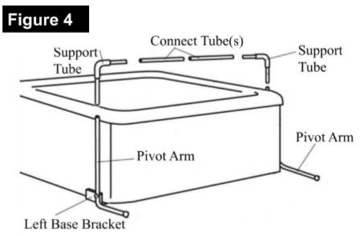

Step 4
Check again the correct position of your cover on your spa.
Depending on the dimensions of your spa, then determine the number of connection tubes required.

Insert the LONG end of each support tube into theends of each swivel arm (Figure 4).

Step 5
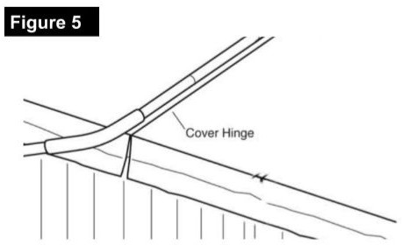
Adjust and center the connecting tube(s) and support arms so that the connecting tube(s) are lying down on the cover,
parallel(s) to the hinge of the spa cover approximately 1/2" or 1.5 cm away (Figure 5).

Step 6
Rotate the tubes so that the pre-existing holes for the self-tapping screws face the back of the spa.

Use the self-tapping screws to attach the swivel arms to the support arms and the support arms to the connection tube(s), and add the black caps on the ends of the screws.

